A Celebration of the Life of
Barbara Patricia
Alexandra Dunford
3rd January 1951 – 6th February 2013
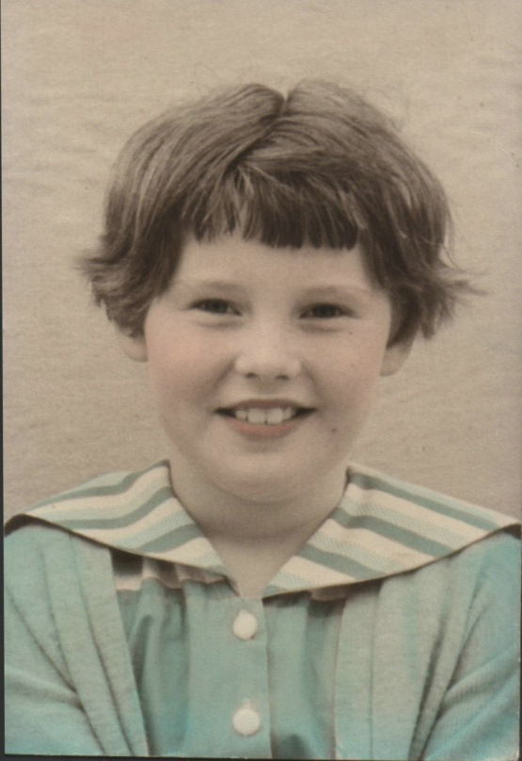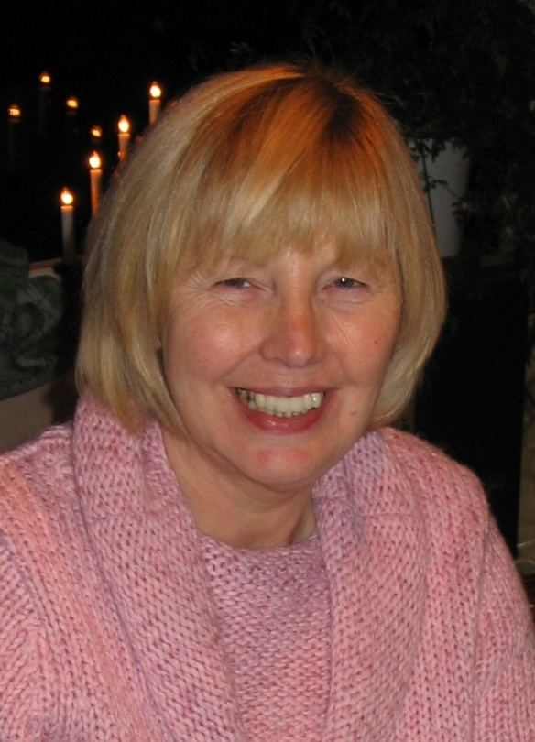
Oxford Crematorium and Garden of Remembrance
Wednesday 27th February 2013, Midday
Conducted by Humanist Celebrant Jacqui Dickenson
ORDER OF SERVICE
Music on Entry
Wonderful Land – The Shadows

Welcome and Introduction
Reading From Ecclesiastes 3:1-8
Read By Kim Buckingham
To everything there is a season,
A time for every purpose under the sun,
A time to be born and a time to die,
A time to plant and a time to pluck up that which is planted,
A time to kill and a time to heal,
A time to weep and a time to laugh,
A time to mourn and a time to dance,
A time to embrace and a time to refrain from embracing,
A time to lose and a time to seek,
A time to rend and a time to sew,
A time to keep silent and a time to speak,
A time to love and a time to hate,
A time for war and a time for peace.

Memories of Barbara
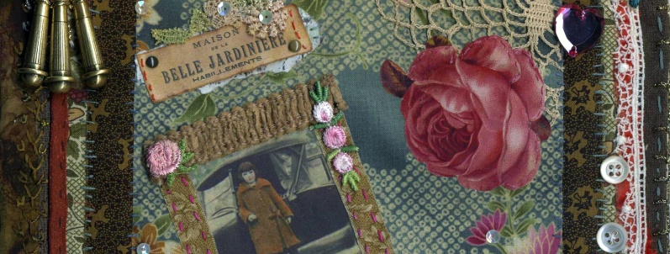
“Waterloo Sunset” by The Kinks
Barbara would like everyone to sing along
Dirty old river, must you keep rolling Flowing into the night
People so busy, makes me feel dizzy
Taxi light shines so bright
But I don't need no friends
As long as I gaze on waterloo sunset
I am in paradise
Every day I look at the world from my window
But chilly, chilly is the evening time
Waterloo sunsets fine
Terry meets Julie, Waterloo station Every Friday night
But I am so lazy, don't want to wander
I stay at home at night
But I don't feel afraid
As long as I gaze on Waterloo sunset
I am in paradise
Every day I look at the world from my window
But chilly, chilly is the evening time
Waterloo sunsets fine
Millions of people swarming like flies round Waterloo underground
But Terry and Julie cross over the river
Where they feel safe and sound
And they don't need no friends
As long as they gaze on Waterloo sunset
They are in paradise
Waterloo sunsets fine

Early Memories of Barbara
Song: “Everlasting Love” by Love Affair

Later Memories of Barbara

“Do Not Stand At My Grave And Weep” by Mary Elizabeth Frye, 1932
Read By Neil and Sue Barnes
Do not stand at my grave and weep
I am not there; I do not sleep.
I am a thousand winds that blow,
I am the diamond glints on snow,
I am the sun on ripened grain,
I am the gentle autumn rain.
When you awaken in the morning's hush,
I am the swift uplifting rush
Of quiet birds in circled flight.
I am the soft stars that shine at night.
Do not stand at my grave and cry,
I am not there; I did not die.
Barbara’s Later Life
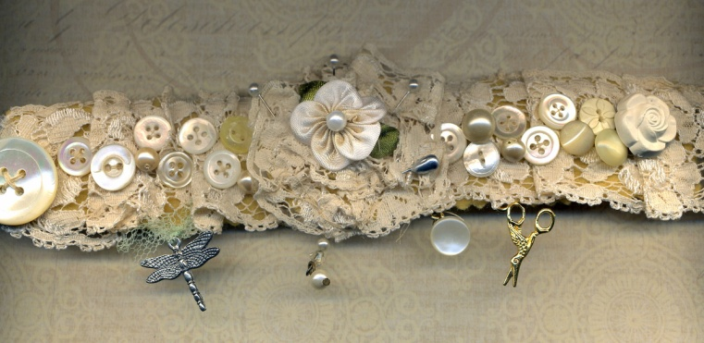
“Forever Autumn” by Justin Haywood
Sung by Lesley Morris,
Accompanied by Keith Harris

The summer sun is fading as the year grows old
And darker days are drawing near
The winter winds will be much colder
Now you’re not here

I watch the birds fly south across the autumn sky
And one by one they disappear
I wish that I was flying with them,
Now you're not here

Like the sun through the trees your came to love me
Like a leaf on a breeze you blew away

Through autumn's golden gown we used to kick our way
You always loved that time of year
Loose fallen leaves lie undisturbed now
Cos you're not here

Like the sun through the trees your came to love me
Like a leaf on a breeze you blew away

A gentle rain falls softly on my weary eyes
As if to hide a lonely tear
My life will be forever autumn
Now you're not here

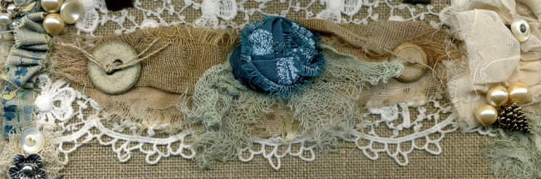
The Committal
Closing Words
Afterglow – Anon
Read By Oliver Barnes

I'd like the memory of me to be a happy one.
I'd like to leave an afterglow of smiles when life is done.
I'd like to leave an echo whispering softly down the ways,
Of happy times and laughing times and bright and sunny days.
I'd like the tears of those who grieve, to dry before the sun;
Of happy memories that I leave when life is done.

Music on Exit
Gypsy – Fleetwood Mac

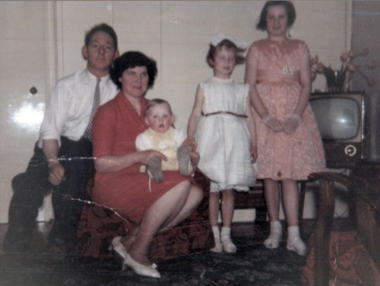
Jack, Pat, Neil, Susan and Barbara
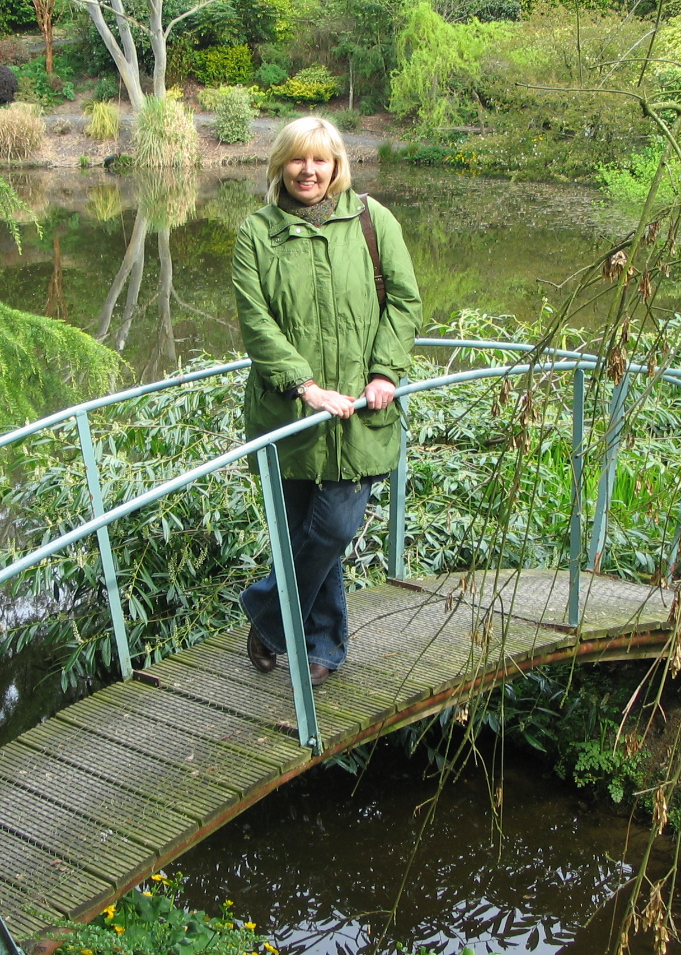
Barbara at the Dingle Garden near Welshpool August 2009

You are most welcome to join the family for refreshments
immediately after the service at:

The Talkhouse
Wheatley Road
Stanton St John
OX33 1EX

3 minutes by car. Turn left onto Bayswater Road and at the T-Junction, turn right. Car park is on the right opposite the pub.

Barbara has requested that donations (rather than flowers) be split between the Donkey Sanctuary and Redwings Horse Sanctuary care of Paul.

